***RUBICON RESTAURANT MANAGEMENT SYSTEM***

***Step1: As we run the application home window appears***

***Like this.***

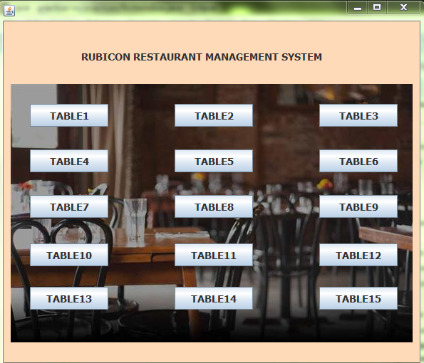

***Here we need to select any table for arriving customers.***

***Let us consider we pressed table 5 button.***

***Step2:Second window appears as follows.***

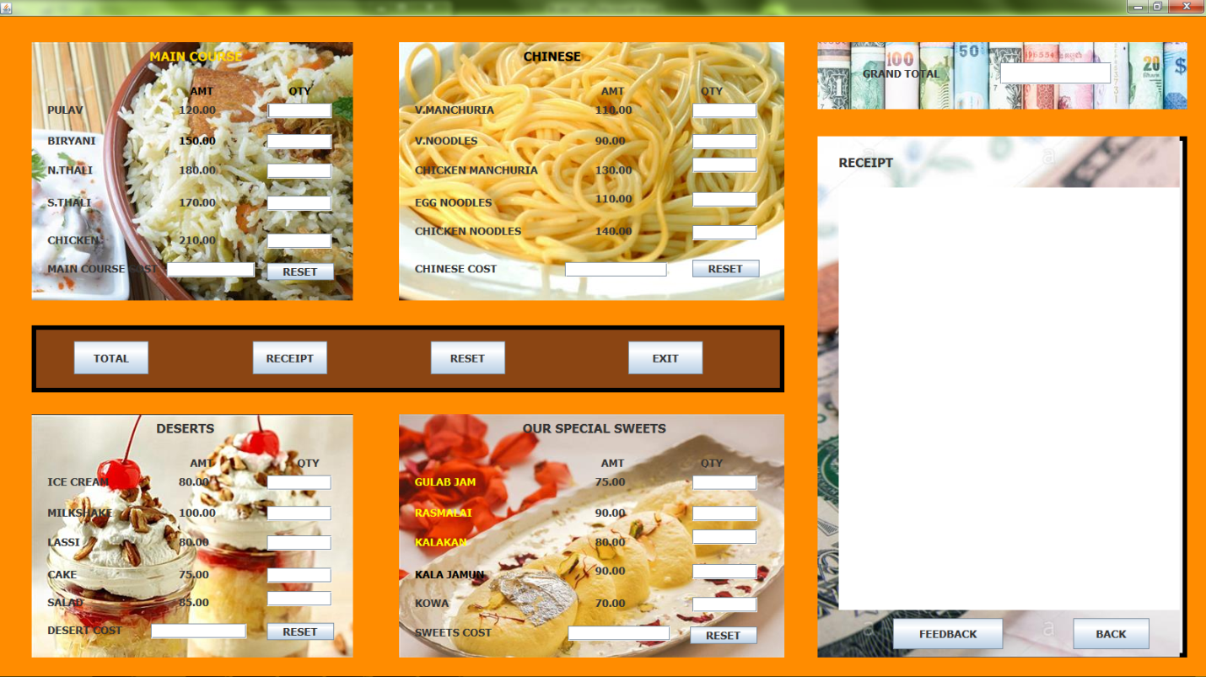

***Here is the menu card and variety dishes offered by our restaurant.***

***If we want to order any dish we need to mention its quantity in the text fields provided respectively.***

***After taking the order window looks like below.***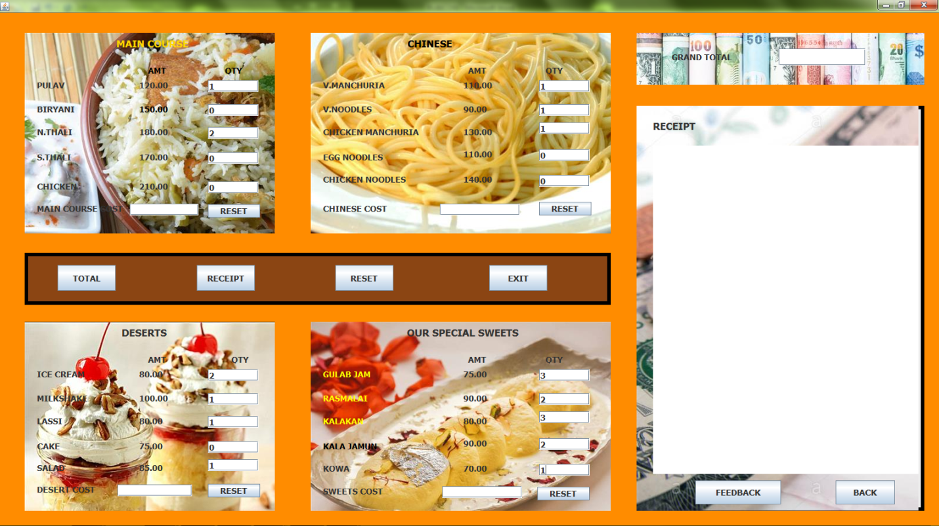

***Step 3:We calculate the total of all the dishes ordered by the customer .As soon as we click total button pop up window shows up like below.***

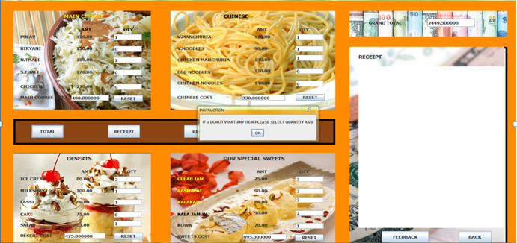

***When we click on ok button total gets generated as follows.***

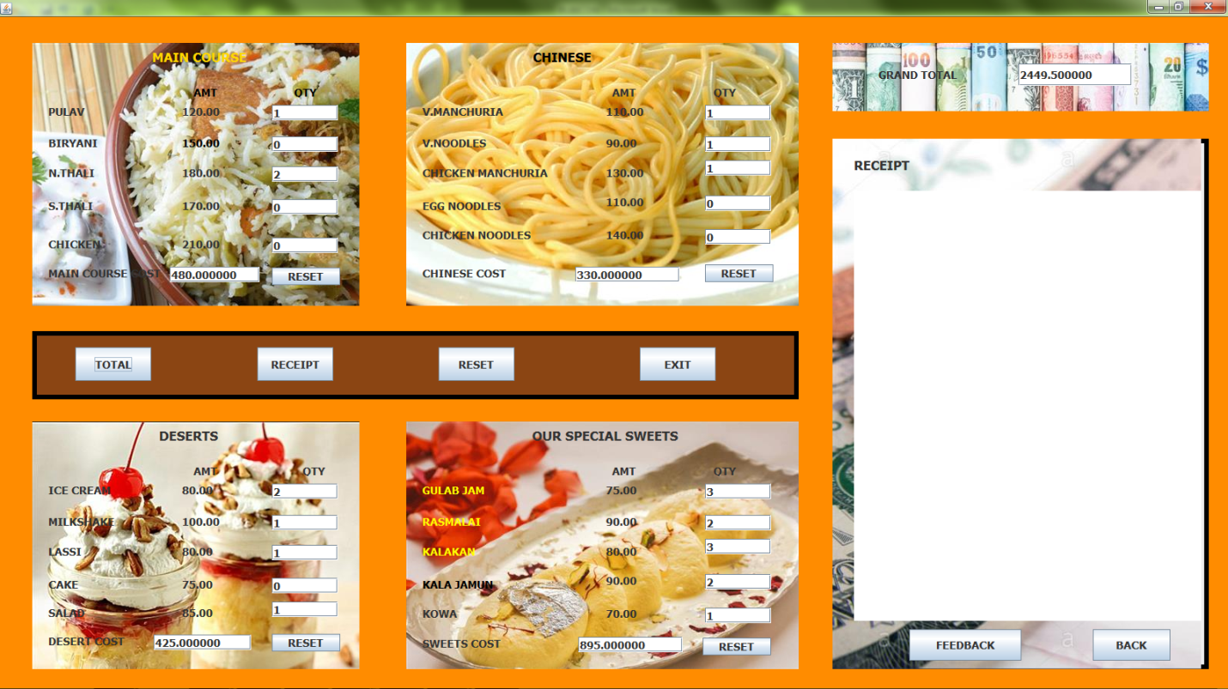

***Step 4:Meanwhile other customers visit our restaurant so we need to accommodate them in other tables, so we***

***Press back button and first window appears .Similar process is followed for other customers too. ***

***step 5:Now if we click button of table 5 again diologue***

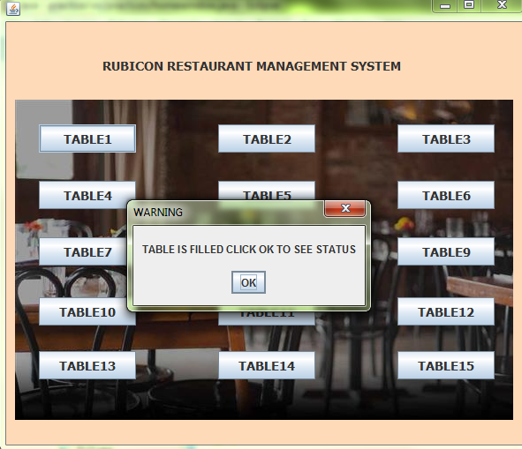

***box appears like above saying table is already filled.As***

***soon as we click ok previous orders of table 1 should show up and we take any further orders.***



***Similarly we accommodate all the customer who visits our restaurant.***

***If we press table 5 for the second time diologue box appears like*** 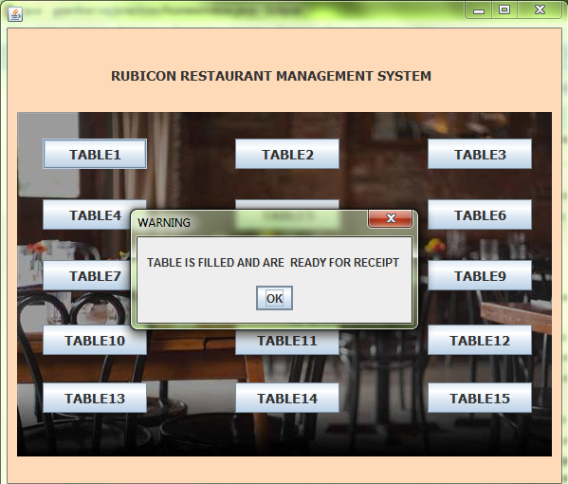

***Step 6:As we click on ok button we will be directed to table 5 orders and as soon as we click on receipt button , receipt appears.***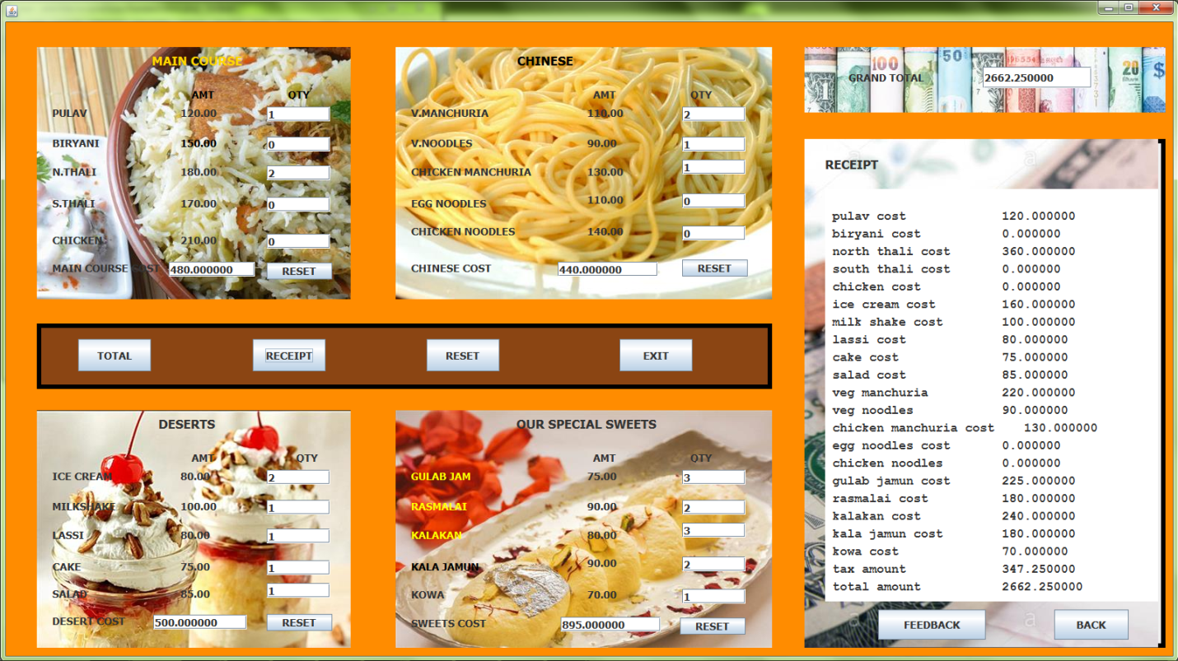

***Step 7:Reset the values and ask the customer to give feedback.***



***Step8: By clicking ok button u will be redirected to tables window.***

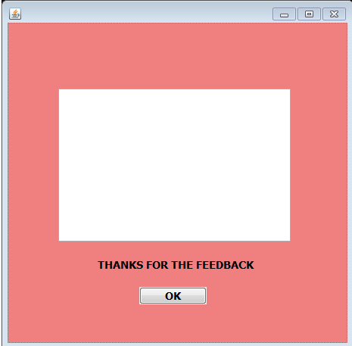

***LIMITATIONS:***

***1) We need to provide 0 as quantity value if we don’t want to order it, as a result we should display dishes we have not ordered and bill them as zero.***

***2) As we are navigating from one window to other window data is lost.***